Simulation Single Phase Shunt Active Filter based on p-q technique using MATLAB/Simulink Development Tools Environment

ABSTRACT
A single phase shunt active power filter based on instantaneous power theory is presented in this paper. The active filter will be connected directly to utility in order to reduce THD of load current, in this case the utility is TNB. The instantaneous power theory also known as p-q theory is used for three phase active filter and this project proves that the p-q theory can also be implemented for single phase active filter. Since the system has only single phase signal for both voltage and current, thus the dummy signal with 120 º different angels must be generated for input of the p-q theory.
In this paper the p-q technique is used which will generate six signals PWM for switching IGBT, but only two of the signals will be used to control the switching IGBT. The simulation results are on MATLAB/Simulink environment tools presented in order to demonstrate the performance of the current load on single phase shunt active power filter. A simulation of single phase shunt active filter is simulated using MATLAB/Simulink. The non-linear load with 3KVA for compensation is connected before single phase diode rectifier.
This paper involves some advantages of implementing shunt active filter on grid power system since it can be installed at housing estate or others system that using single phase grid power system. The aim of this project is to implement the p-q theory in single phase shunt active filter connected directly to gird power system. The technique is simulated by using MATLAB/Simulink simulation development tools environment.

Block diagram for proposed system
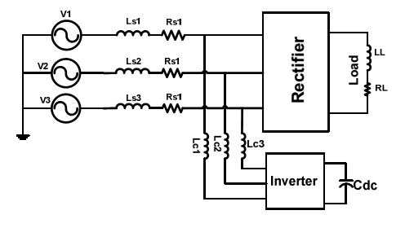
DESIGNG SOFTWARE AND TOOLS:
MATLAB /SIMULATION Software and simpower systems tools are used. Mainly control system tools, power electronics and electrical elements tools are used.

